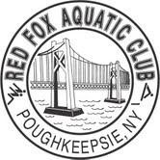
Red Fox Aquatic Club Vision Statement

The paradigm of the RED FOX AQUATIC CLUB is always MIND – BODY – SPIRIT. Our vision is to provide an effective means for our members to realize their full potential in the sport of competitive swimming while instilling the values of sportsmanship, discipline, and focus on individual and team goal achievement.
RFAC will provide a Safe and Supportive environment for all members of RFAC and USA Swimming.

